**Group 1: Americanisation**

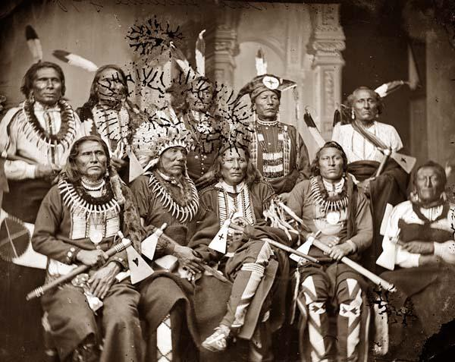

**Work in pairs (or groups of 3) and start researching on**

<http://en.wikipedia.org/wiki/Americanization_of_Native_Americans>

Deepen your research with these links

* <http://www.allabouthistory.org/native-american-history.htm>
* <http://freedmenvscherokeenation.blogspot.com/2008/08/americanization-of-native-americans.html>

**Be ready to present your findings in the next lesson (ca. 3-5 minutes)! Create a summarising PPP (including 1-2 pictures and all your group names) focusing on:**

1. The definition of Americanisation of Native Americans
2. The Americanisation policies
3. The making of American citizens (how do Native Americans become citizens of the US)

* **Preparation time: 25 minutes**
* **Send your PPP to the teacher the day before the mini presentations at the latest!**
* **1-2 groups in your category will present their results.**

**Group 2: Native American education and boarding schools**

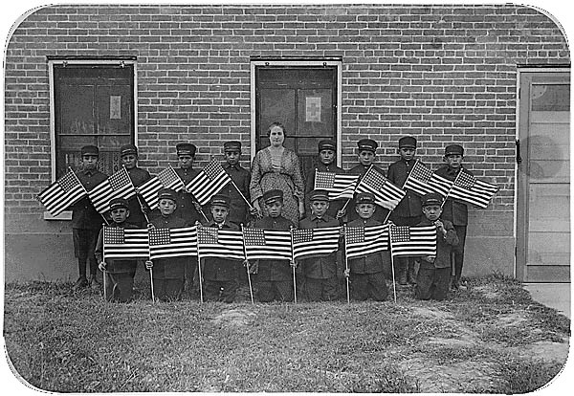

**Work in pairs (or groups of 3) and start researching on**

<https://en.wikipedia.org/wiki/American_Indian_boarding_schools>

Then deepen your research with these links

* <http://www.allabouthistory.org/native-american-history.htm>
* <http://freedmenvscherokeenation.blogspot.com/2008/08/americanization-of-native-americans.html>

**Be ready to present your findings in the next lesson (ca. 3-5 minutes)! Create a summarising PPP (including 1-2 pictures and all your group names) focusing on:**

1. Life of an Indian child at an Indian boarding school in the late 19th century
2. The educational principle of Richard Henry Pratt
3. Indian education today

* **Preparation time: 25 minutes**
* **Send your PPP to the teacher the day before the mini presentations at the latest!**
* **1-2 groups in your category will present their results.**